Q1) Explain user defined data types.

User defined data type are known as Non-primitive data types. It is also known as reference type.
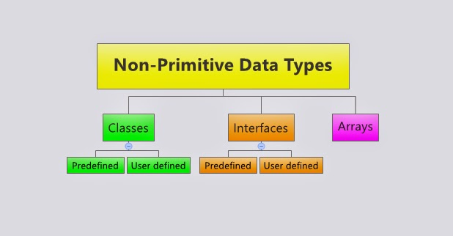

Q2) Differentiate Primitive data type and user defined data type in Java.
- Primitive data types: The primitive data types include boolean, char, byte, short, int, long, float and double.
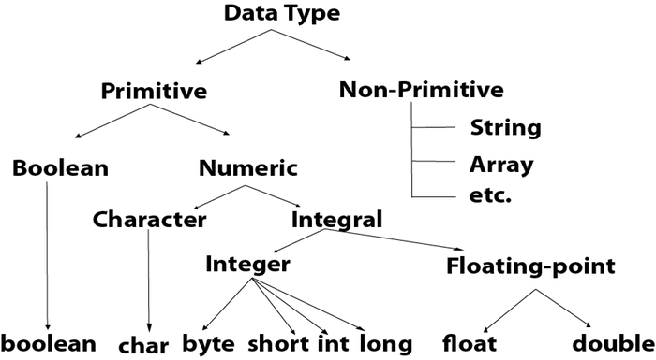

Non-primitive data types:

- The non-primitive data types include Classes, Interfaces, and Arrays. Also known as userdefined data types
Q3) Define Identifiers & Literals in Java

Identifier
An Identifier is needed to name a variable.
An identifier is sequence of character, of any length, comprising uppercase and lowercase letters (a-z, A-Z), digits (0-9z), underscore _ and dollar sign $.
Literals
A literal is a specific constant value or raw data, such as 123, -456, 3.14, 'a', "hello", that is used in the program source.
They are called literals because they literally and explicitly identify their values.
It can be of any Java data types.

Q4) How to declare constant & variable in Java?
Variable is name of reserved area allocated in memory.
Example: int a=5; (a is variable and its value is 5)
Constant are declared with keyword final. Their values cannot be changed during program.
Example: Final double pi=3.14;
Q5) What is type casting? Why it is required in programming
Typecasting, or type conversion, is a method of changing an entity from one data type to another. It is used in computer programming to ensure variables are correctly processed by a function.
An example of typecasting is converting an integer to a string.
In Java, there are two types of casting:
- Widening Casting (automatically)(Implicit type) - converting a smaller type to a larger type size
byte -> short -> char -> int -> long -> float -> double
- Narrowing Casting (manually)(Explicit type) - converting a larger type to a smaller size type
double -> float -> long -> int -> char -> short -> byte

Widening Casting
Widening casting is done automatically when passing a smaller size type to a larger size type:
public class MyClass {
public static void main(String[] args) {
int myInt = 9;
double myDouble = myInt; // Automatic casting: int to double
System.out.println(myInt); // Outputs 9
System.out.println(myDouble); // Outputs 9.0
}}

Narrowing Casting
Narrowing casting must be done manually by placing the type in parantheses in front of the value:
public class MyClass {
public static void main(String[] args) {
double myDouble = 9.78;
int myInt = (int) myDouble; // Manual casting: double to int
System.out.println(myDouble); // Outputs 9.78
System.out.println(myInt); // Outputs 9
}
}

Q6) Explain scope of variables in java

Scope of variables
A variables scope is the region of a program within the variable Can be referred by its simple name.
Scope also determines when the system creates and destroys memory for the variables.
The location of the variables declaration within your program establish its scope and places it into one of these our categories.
- Member variable
- Local variable
- Method parameter
- exception-handler parameter

Q7) Explain Wrapper class.

Wrapper class in java provides the mechanism to convert primitive into object and object into primitive.
Importance of Wrapper classes
there are mainly two uses with wrapper classes.
1) To convert simple data types into objects, that is, to give object form to a data type; here constructors are used.
2) To convert strings into data types (known as parsing operations), here methods of type parseXXX() are used.
Features of the Java wrapper Classes.
1) Wrapper classes convert numeric strings into numeric values.
2) The way to store primitive data in an object.
3) The valueOf() method is available in all wrapper classes except Character
4) All wrapper classes have typeValue() method. This method returns the value of the object as its primitive type.
Primitive Data Type | Wrapper Class
byte | Byte
short | Short
int | Integer
long | Long
float | Float
double | Double
boolean | Boolean
char | Character

Examples of wrapper class
- 1) converting int to Integer

- public class WrapperExample1{
- public static void main(String args[]){
- //Converting int into Integer
- int a=20;
- Integer i=Integer.valueOf(a);//converting int into Integer
- Integer j=a;//autoboxing, now compiler will write Integer.valueOf(a) internally

- System.out.println(a+" "+i+" "+j);
- }}

2) using Integer,Double and Character wrapper class
public class MyClass {
public static void main(String[] args) {
Integer myInt = 5;
Double myDouble = 5.99;
Character myChar = 'A';
System.out.println(myInt);
System.out.println(myDouble);
System.out.println(myChar);
}
}

3) using valueOf () methods(it assigns variable values to objects)
- Integer i2=Integer.valueOf(“101011”2);{assigns value t object i2}
- Float f2=Float.valueOf(“3.14f”);{assigns value 3.14f to object f2}

Q8)Explain garbage collection java
In java, garbage means unreferenced objects. Garbage Collection is process of reclaiming the runtime unused memory automatically. In other words, it is a way to destroy the unused objects. in java it is performed automatically. So, java provides better memory management.

Advantage of Garbage Collection
- It makes java memory efficient because garbage collector removes the unreferenced objects from heap memory.
- It is automatically done by the garbage collector(a part of JVM) so we don't need to make extra efforts.
Example
- public class TestGarbage1{
- public void finalize(){System.out.println("object is garbage collected");}
- public static void main(String args[]){
- TestGarbage1 s1=new TestGarbage1();
- TestGarbage1 s2=new TestGarbage1();
- s1=null;
- s2=null;
- System.gc();
- }
- }

Q9) Which function is used to perform some action when the object is to be destroyed?

gc() method
The gc() method is used to invoke the garbage collector to perform cleanup processing. The gc() is found in System and Runtime classes.
public static void gc(){}

Q10) What is command line argument?
The java command-line argument is an argument i.e. passed at the time of running the java program.
- Example  class CommandLineExample{  public static void main(String args[])  {  System.out.println("My name is: "+args[0]);  }  }  compile by > javac CommandLineExample.java  run by > java CommandLineExample Arhanti  Output  My name is: Arhanti | - Example (to print multiple values)  - class A{  - public static void main(String args[]){  - for(int i=0;i<args.length;i++)  - System.out.println(args[i]); }  - }  compile by > javac A.java  run by > java A Arhanti IT BMP  Output  Arhanti IT BMP

Q11) Write a Java Program to display the 3 city names using the command-line argument

class city{
public static void main(String args[])
{
for(int i=0;i<args.length;i++)
{
System.out.println(args[i]);
}
}
}
compile by > javac city.java
run by > java city Ahmedabad Mumbai Surat
Output
Ahmedabad Mumbai Surat

Q12) Write a Java program to read two strings from command line argument and check the equality of two string using string function.
Public class stringfunction
{
Public static void main (String args[])
{
System.out.println(args[0]);
System.out.println(args[1]);
String s1=args[0]
String s2=args[1]
System.out.println(s1.equals(s2));}
}

Q13) Write a program to read five integer numbers from command line and display their sum and average.
public class sum
{
Public static void main(String args[]
{
String rs
int arg1,arg2,result,avg;
arg1=Integer.parseInt(args[0]);
arg2=Integer.parseInt(args[1]);
arg3=Integer.parseInt(args[2]);
arg4=Integer.parseInt(args[3]);
arg5=Integer.parseInt(args[4]);
result=arg1+arg2+arg3+arg4+arg5;
avg=result/5;
rs=Integer.toString(result)
System.out.println(“sum is:” + “ “ + rs);
System.out.println(“average is:” + “ “ + avg);
}}}

Q14) Explain types of Array
- Single dimensional
- Two dimensational
- Multidimensationa
- Non rectangular array(variable type)

Q15) Explain arrays in Java.

Java array is an object which contains elements of a similar data type. It is a data structure where we store similar elements. We can store only a fixed set of elements in a Java array.
Array in java is index-based; the first element of the array is stored at the 0 index.
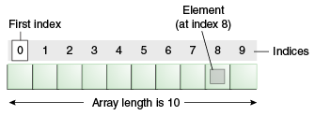

There are three steps to create an array
- Declaration
- Construction
- Initialization

1 ) Declaration
It includes name and type of array
Syntax: type array_name[] OR type[] array_name
Example: int array1[]
Double[] array2;
2) Construction
It specifies size of an array
Syntax: array_name=new type [size]
Example: array1=new int [25];
- Initialization
It stores value in array
Int array1[];
array1=new int [5];
array1 [0] =1
array1 [1] =2;
array1[2]=3;
array1[3]=4;
array1[4]=5;

Example of single dimensional Array
- class Testarray{
- public static void main(String args[]){
- int a[]=new int[5];//declaration and instantiation
- a[0]=10;//initialization
- a[1]=20;
- a[2]=70;
- a[3]=40;
- a[4]=50;
- //traversing array
- for(int i=0;i<a.length;i++)//length is the property of array
- System.out.println(a[i]);
- }}

Output
10
20
70
40
50

Q16) Explain two dimensional or multidimensional array in java
Declaration:
Int array[][];//two dimensional
Int array[][][];//multidimensional
1 | 5
2 | 6
3 | 7
rows
Construction
Column
array[][]=new int[3][2]; //two dimensional
array[][][]=new int[3][2][1];// multidimensional
Initialization
Int array[3][2] = { {1, 2, 3, }, {5, 6,7 } };
Int array[][][]={{12,3}{5,6},{3}};
Example
public class MyClass {
public static void main(String[] args) {
int[][] myNumbers = { {1, 2, 3}, {5, 6, 7} };
for (int i = 0; i < myNumbers.length; ++i) {
for(int j = 0; j < myNumbers[i].length; ++j) {
System.out.println(myNumbers[i][j]);
}
}
}
}

Q17) Explain non rectangular array
In array it is compulsory to allocate memory for first dimension.
Ex: int[2][]; valid
int[][3]; invalid
in non rectangular array no of rows are fixed but no of column will vary for each row.
Row[1]:column[5]
Row[2]:column[3]
Row[3]:column[2]
Row[4]:column[4]
Example
Class rectangulararray
{
Public static void main(String args[]
{
Int array[][]=new int[5][];
array[0]=new int[1];
array[1]=new int[2];
array[2]=new int[3];
array[3]=new int[4];
array[4]=new int[5];
for (i=0i<4;i++)
{
For(int j=0j<i;j++)
{
array[i][j]=i+1;
System.out.println(array[i][j])
}
System.out.println(“ “);}}}
Output
1
12
123
1234
12345

Q18) List types of array and Explain variable type (Non Rectangular type) array with example.
Ans: Q14) and Q17)

Q19) Write java program to find length of array in java
public class JavaStringArrayLengthExample {

public static void main(String args[]){
//create String array
String[] strArray = new String[]{"Java", "String", "Array", "Length"};

// To get length of array, use length property of array.

int length = strArray.length;
System.out.println("String array length is: " + length);

//print elements of an array
for(int i=0; i < length; i++){
System.out.println(strArray[i]);}}}

Output
String array length is: 4
Java
String
Array
Length

Q20)Write a Java Program to sort array of 5 integer numbers in ascending order

- public class InsertSort {
- public static void main (String [] args) {
- int [] array = {45,12,85,32,89};
- int temp;
- for (int i = 1; i < array.length; i++) {
- for (int j = i; j > 0; j--) {
- if (array[j] < array [j - 1]) {
- temp = array[j];
- array[j] = array[j - 1];
- array[j - 1] = temp;
- }
- }
- }
- for (int i = 0; i < array.length; i++) {
- System.out.println(array[i]);
- }
- }
- }

Q21) Write a java program to sum of two dimensional matrix using array.
- public class MatrixAdditionExample{
- public static void main(String args[]){
- //creating two matrices
- int a[][]={{1,3,4},{2,4,3},{3,4,5}};
- int b[][]={{1,3,4},{2,4,3},{1,2,4}};

- //creating another matrix to store the sum of two matrices
- int c[][]=new int[3][3]; //3 rows and 3 columns

- //adding and printing addition of 2 matrices
- for(int i=0;i<3;i++){
- for(int j=0;j<3;j++){
- c[i][j]=a[i][j]+b[i][j]; //use - for subtraction
- System.out.print(c[i][j]+" ");
- }
- System.out.println();//new line
- } }}

Q22) Explain String in Java
In Java, string is an object that represents a sequence of characters. The java.lang.String class is used to create a string object.

How to create a string object?
There are two ways to create String object:
- By string literal
- By new keyword

1) String Literal
Java String literal is created by using double quotes. For Example:
String s="welcome";
Each time you create a string literal, the JVM checks the "string constant pool" first. If the string already exists in the pool, a reference to the pooled instance is returned. If the string doesn't exist in the pool, a new string instance is created and placed in the pool. For example:
String s1="Welcome";
String s2="Welcome";//It doesn't create a new instance

2) By new keyword
String s=new String("Welcome");//creates two objects and one reference variable
In such case, JVM will create a new string object in normal (non-pool) heap memory, and the literal "Welcome" will be placed in the string constant pool. The variable s will refer to the object in a heap (non-pool).

Java String Example
- public class StringExample{
- public static void main(String args[]){
- String s1="java";//creating string by java string literal
- char ch[]={'s','t','r','i','n','g','s'};
- String s2=new String(ch);//converting char array to string
- String s3=new String("example");//creating java string by new keyword
- System.out.println(s1);
- System.out.println(s2);
- System.out.println(s3);
- }}

Q23) List methods of Java String class
- String charAt()
- String compareTo()
- String concat()
- String equals()
- equalsIgnoreCase()
- String getChars()
- String isEmpty()
- String length()
- String startsWith()
- String substring()
- String toLowerCase()
- String toUpperCase()
- String trim()
- String valueOf()

Q24) Explain any four string function in java with example

Java String charAt()
The java string charAt() method returns a char value at the given index number.
- public class CharAtExample{
- public static void main(String args[]){
- String name="javatpoint";
- char ch=name.charAt(4);//returns the char value at the 4th index
- System.out.println(ch);
- }}

Java String equals()
The java string equals() method compares the two given strings based on the content of the string. If any character is not matched, it returns false. If all characters are matched, it returns true.
- public class EqualsExample{
- public static void main(String args[]){
- String s1="javatpoint";
- String s2="javatpoint";
- String s3="JAVATPOINT";
- String s4="python";
- System.out.println(s1.equals(s2));//true because content and case is same
- System.out.println(s1.equals(s3));//false because case is not same
- System.out.println(s1.equals(s4));//false because content is not same
- }}

Java String toLowerCase()
The java string toLowerCase() method returns the string in lowercase letter. In other words, it converts all characters of the string into lower case letter.
- public class StringLowerExample{
- public static void main(String args[]){
- String s1="JAVATPOINT HELLO stRIng";
- String s1lower=s1.toLowerCase();
- System.out.println(s1lower);
}} OUTPUT: javatpoint hello string

Java String concat
The java string concat() method combines specified string at the end of this string. It returns combined string. It is like appending another string.
- public class ConcatExample{
- public static void main(String args[]){
- String s1="java string";
- s1.concat("is immutable");
- System.out.println(s1);
- s1=s1.concat(" is immutable so assign it explicitly");
- System.out.println(s1);
- }}
OUTPUT
java string
java string is immutable so assign it explicitly

Q25) List methods of String class. Explain how to use String class.

Ans: Q22 and Q23

Q26) What is mutable in immutable string?
A string that can be modified or changed is known as mutable string. StringBuffer and StringBuilder classes are used for creating mutable string.
In java, string objects are immutable. Immutable simply means unmodifiable or unchangeable.
Once string object is created its data or state can't be changed but a new string object is created.

Q27) Why string objects are immutable in java?
Because java uses the concept of string literal.Suppose there are 5 reference variables,all referes to one object "sachin".If one reference variable changes the value of the object, it will be affected to all the reference variables. That is why string objects are immutable in java.

Method | Description
append(String s) | is used to append the specified string with this string. The append() method is overloaded like append(char), append(boolean), append(int), append(float), append(double) etc.
insert(int offset, String s) | is used to insert the specified string with this string at the specified position. The insert() method is overloaded like insert(int, char), insert(int, boolean), insert(int, int), insert(int, float), insert(int, double) etc.
replace(int startIndex, int endIndex, String str) | is used to replace the string from specified startIndex and endIndex.
delete(int startIndex, int endIndex) | is used to delete the string from specified startIndex and endIndex.
reverse() | is used to reverse the string.
capacity() | is used to return the current capacity.
ensureCapacity(int minimumCapacity) | is used to ensure the capacity at least equal to the given minimum.
charAt(int index) | is used to return the character at the specified position.
length() | is used to return the length of the string i.e. total number of characters.
substring(int beginIndex) | is used to return the substring from the specified beginIndex.
substring(int beginIndex, int endIndex) | is used to return the substring from the specified beginIndex and endIndex.
Q28) List methods of String Buffer class. Explain how to use String buffer class.

Java StringBuffer class is used to create mutable (modifiable) string. The StringBuffer class in java is same as String class except it is mutable i.e. it can be changed.

Example
- class StringBufferExample{
- public static void main(String args[]){
- StringBuffer sb=new StringBuffer("Hello ");
- sb.append("Java");//now original string is changed
- System.out.println(sb);//prints Hello Java
- }
- }

Q29) Write a Java program to reverse a given string.
class ReverseofaString
{
public static void main(String[ ] arg)
{
String str;
Scanner scan=new Scanner(System.in);
System.out.print("Enter a string : ");
str=scan.nextLine();
char[] ch=str.toCharArray();
System.out.println("Reverse of a String is :");
int j=ch.length;
for(int i=j;i>0;i--)
{
System.out.print(ch[i-1]);
}
}
}

Q30)Write a Java Program to check given number is Palindrome or not.
- class PalindromeExample{
- public static void main(String args[]){
- int r,sum=0,temp;
- int n=454;//It is the number variable to be checked for palindrome

- temp=n;
- while(n>0){
- r=n%10; //getting remainder
- sum=(sum*10)+r;
- n=n/10;
- }
- if(temp==sum)
- System.out.println("palindrome number ");
- else
- System.out.println("not palindrome");
- }
- }

Q31) Differentiate string class v/s string buffer class.
No. | String | StringBuffer
1) | String class is immutable. | StringBuffer class is mutable.
2) | String is slow and consumes more memory when you concat too many strings because every time it creates new instance. | StringBuffer is fast and consumes less memory when you cancat strings.
3) | String class overrides the equals() method of Object class. So you can compare the contents of two strings by equals() method. | StringBuffer class doesn't override the equals() method of Object class.

Q32) List types of Operators in JAVA
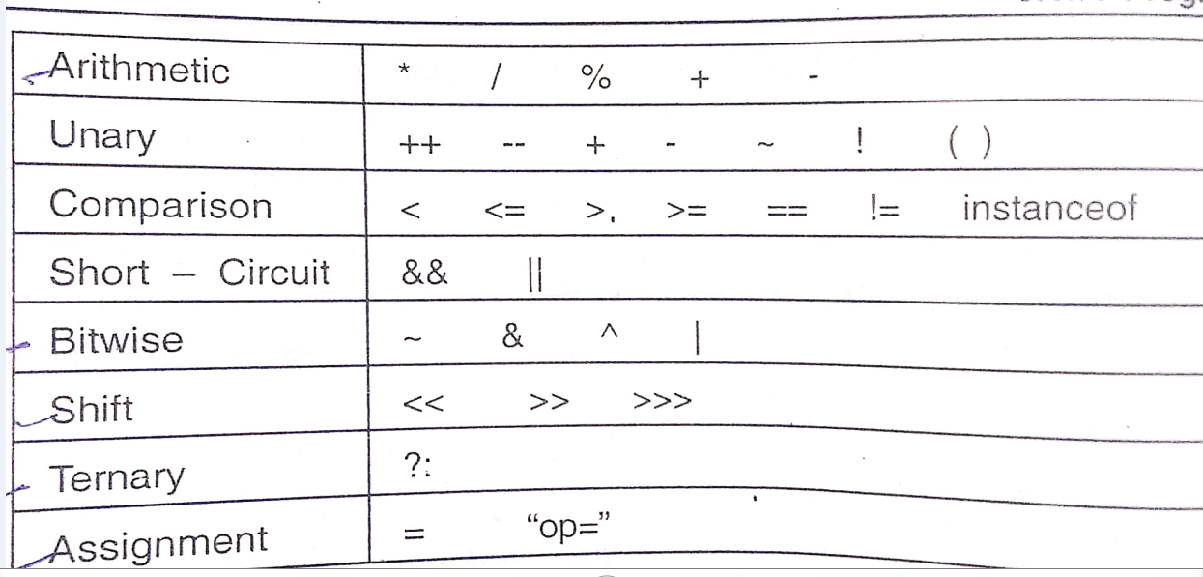

Q33) List out Bitwise operators.
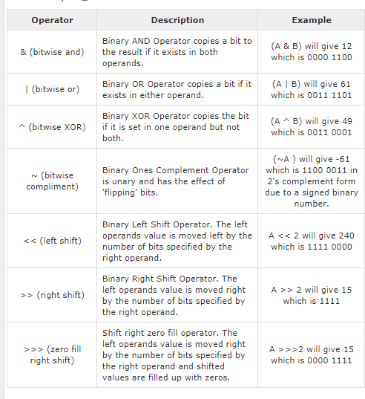

Q34) Perform bitwise & operation
A=5
B=3
Ans:
A=3=1100  B=5=1010 | A&B  1100  &1010  1000  Final answer  1000=1
Q35) Explain java ternary operator
- Example:
- class OperatorExample{
- public static void main(String args[]){
- int a=2;
- int b=5;
- int min=(a<b)?a:b;
- System.out.println(min);
- }}
- Output: 2

Java Ternary operator is used as one liner replacement for if-then-else statement and used a lot in java programming. it is the only conditional operator which takes three operands.

Q36) List the shift operators available in Java

<< (left shift) | Binary Left Shift Operator. The left operands value is moved left by the number of bits specified by the right operand. | A << 2 will give 240 which is 1111 0000
>> (right shift) | Binary Right Shift Operator. The left operands value is moved right by the number of bits specified by the right operand. | A >> 2 will give 15 which is 1111
>>> (zero fill right shift) | Shift right zero fill operator. The left operands value is moved right by the number of bits specified by the right operand and shifted values are filled up with zeros. | A >>>2 will give 15 which is 0000 1111

Q37) Explain Java Shift Operator Example: >> vs >>>
- class OperatorExample{
- public static void main(String args[]){
- //For positive number, >> and >>> works same
- System.out.println(20>>2);
- System.out.println(20>>>2);
- //For negative number, >>> changes parity bit (MSB) to 0
- System.out.println(-20>>2);
- System.out.println(-20>>>2);
- }}
Output:5
5
-5
1073741819

Q38) Which of these is not a bitwise operator?
a) & b) &= c) |= d) <=
Ans: a) &

Q39) Determine the value of each of the following logical expression
if a = 5,b = 10 and c = - 6
(a) a== c || b>a
(b) b > 15 && c < 0 || a > 0

Ans:

(a) a== c || b>a
a==c: | || | b>a | Answer
5==6  false | || | 10>5  true | False||True=True

In logical OR operation false||True=True
So final answer is :True

(b) b > 15 && c < 0 || a > 0
b>15 | && | C<0 | || | a>0
10>15  False | && | 6<0  False | || | 5>0  True
False | && | False | || | True
False && false=false
False||true=true
So final answer is: True

Q40) Write a program in Java to reverse the digits of a number using while loop
- public class ReverseNumber {

- public static void main(String[] args) {

- int num = 1234, reversed = 0;

- while(num != 0) {
- int digit = num % 10;
- reversed = reversed * 10 + digit;
- num /= 10;
- }
- System.out.println("Reversed Number: " + reversed);
- }
- }

Q41) Distinguish between break and continue statements in Java.
Distinguish between break and continue statements in Java.  Example  Output  Break Statement...............  1  2  3 | The continue keyword is used to skip the particular recursion only in a loop execution, which may be a for loop, while loop, do while or for each loop.  Example  Output  Continue Statement....................  2  3  4  5
  class BreakAndContinue
  {
  public static void main(String args[])
  {
  System.out.println("Break Statement.");
  for(int i=1;i<=5;i++)
  {
  if(i==4) break;
  System.out.println(i);
  }
  System.out.println("Continue Statement");
  for(int i=1;i<=5;i++)
  {
  if(i==1) continue;
  System.out.println(i);
  }
  }}}
  class BreakAndContinue
  {
  public static void main(String args[])
  System.out.println("Break Statement\
  for(int i=1;i<=5;i++)
  {
  if(i==4) break;
  System.out.println(i);
  }
  System.out.println("Continue Statement");
  for(int i=1;i<=5;i++)
  {
  if(i==1) continue;
  System.out.println(i);
  }
  }}
Q42) List control statements in Java
- if statement
- if-else statement
- if-else-if ladder
- nested if statement
- Switch case

